**1. Create Table Student (Rollno, Name, Class, contact). Create an Android Application for performing the insert and display operation on the table. (Using SQLite Database).**

**Xml code**

*<?*xml version="1.0" encoding="utf-8"*?>*<RelativeLayout xmlns:android="http://schemas.android.com/apk/res/android"  
 xmlns:app="http://schemas.android.com/apk/res-auto"  
 xmlns:tools="http://schemas.android.com/tools"  
 android:layout_width="match_parent"  
 android:layout_height="match_parent"  
 tools:context=".MainActivity"  
 android:orientation="vertical">  
  
 <TextView  
 android:layout_width="wrap_content"  
 android:layout_height="wrap_content"  
 android:id="@+id/t1"  
 android:text="Student Details"  
 android:layout_marginTop="30dp"  
 android:layout_marginLeft="100dp"  
 android:textColor="@color/black"  
 android:textStyle="bold"  
 android:textSize="25sp"/>  
 <TextView  
 android:layout_width="wrap_content"  
 android:layout_height="wrap_content"  
 android:layout_below="@+id/t1"  
 android:id="@+id/t2"  
 android:text="Enter Roll no:"  
 android:textSize="20sp"  
 android:textStyle="bold"  
 android:layout_marginTop="15dp"  
 android:layout_marginLeft="15dp"/>  
 <EditText  
 android:id="@+id/e1"  
 android:layout_width="match_parent"  
 android:layout_height="wrap_content"  
 android:layout_below="@+id/t1"  
 android:layout_marginLeft="140dp"  
 android:layout_marginTop="3dp"  
 android:layout_marginRight="20dp"  
 />  
  
 <TextView  
 android:layout_width="wrap_content"  
 android:layout_height="wrap_content"  
 android:id="@+id/t3"  
 android:layout_below="@+id/e1"  
 android:text="Enter Name:"  
 android:textSize="20sp"  
 android:textStyle="bold"  
 android:layout_marginTop="15dp"  
 android:layout_marginLeft="15dp"/>  
 <EditText  
 android:layout_width="match_parent"  
 android:layout_height="wrap_content"  
 android:layout_below="@+id/e1"  
 android:layout_marginLeft="140dp"  
 android:layout_marginTop="3dp"  
 android:layout_marginRight="20dp"  
 android:id="@+id/e2" />  
 <TextView  
 android:layout_width="wrap_content"  
 android:layout_height="wrap_content"  
 android:id="@+id/t4"  
 android:layout_below="@+id/e2"  
 android:text="Enter Class:"  
 android:textSize="20sp"  
 android:textStyle="bold"  
 android:layout_marginTop="15dp"  
 android:layout_marginLeft="15dp"/>  
 <EditText  
 android:layout_width="match_parent"  
 android:layout_height="wrap_content"  
 android:layout_below="@+id/e2"  
 android:layout_marginLeft="140dp"  
 android:layout_marginTop="3dp"  
 android:layout_marginRight="20dp"  
 android:id="@+id/e3" />  
 <TextView  
 android:layout_width="wrap_content"  
 android:layout_height="wrap_content"  
 android:id="@+id/t5"  
 android:layout_below="@+id/t4"  
 android:text="Enter Phone no:"  
 android:textSize="20sp"  
 android:textStyle="bold"  
 android:layout_marginTop="15dp"  
 android:layout_marginLeft="15dp"/>  
 <EditText  
 android:layout_width="match_parent"  
 android:layout_height="wrap_content"  
 android:layout_below="@+id/t4"  
 android:layout_marginLeft="160dp"  
 android:layout_marginTop="3dp"  
 android:layout_marginRight="20dp"  
 android:id="@+id/e4" />  
 <Button  
 android:layout_width="wrap_content"  
 android:layout_height="wrap_content"  
 android:id="@+id/b1"  
 android:text="Insert"  
 android:layout_below="@id/t5"  
 android:layout_marginLeft="40dp"  
 android:layout_marginTop="20dp"/>  
  
 <Button  
 android:id="@+id/b2"  
 android:layout_width="wrap_content"  
 android:layout_height="wrap_content"  
 android:layout_marginLeft="200dp"  
 android:layout_below="@id/t5"  
 android:layout_marginTop="20dp"  
 android:text="Display" />  
</RelativeLayout>

**Java code**

package com.example.studentdatabse;  
  
import androidx.appcompat.app.AppCompatActivity;  
  
import android.os.Bundle;  
import android.app.Activity;  
import android.app.AlertDialog.Builder;  
import android.content.Context;  
import android.database.Cursor;  
import android.database.sqlite.SQLiteDatabase;  
import android.view.View;  
import android.view.View.OnClickListener;  
import android.widget.Button;  
import android.widget.EditText;  
  
public class MainActivity extends AppCompatActivity implements OnClickListener {  
 EditText Rollno, Name, Class,Phno;  
 Button Insert,ViewAll;  
 SQLiteDatabase db;  
  
 @Override  
 protected void onCreate(Bundle savedInstanceState) {  
 super.onCreate(savedInstanceState);  
 setContentView(R.layout.*activity_main*);  
 Rollno = (EditText) findViewById(R.id.*e1*);  
 Name = (EditText) findViewById(R.id.*e2*);  
 Class = (EditText) findViewById(R.id.*e3*);  
 Phno=(EditText) findViewById(R.id.*e4*);  
 Insert = (Button) findViewById(R.id.*b1*);  
 ViewAll = (Button) findViewById(R.id.*b2*);  
 Insert.setOnClickListener(this);  
 ViewAll.setOnClickListener(this);  
 db = openOrCreateDatabase("StudentDB1", Context.*MODE_PRIVATE*, null);  
 db.execSQL("CREATE TABLE IF NOT EXISTS students(rollno VARCHAR,name VARCHAR,class VARCHAR,phno VARCHAR);");  
 }  
 public void onClick(View view) {  
 if (view == Insert) {  
 if (Rollno.getText().toString().trim().length() == 0 ||  
 Name.getText().toString().trim().length() == 0 ||  
 Class.getText().toString().trim().length() == 0||  
 Phno.getText().toString().trim().length() == 0)  
 {  
 showMessage("Error", "Please enter all values");  
 return;  
 }  
 db.execSQL("INSERT INTO students VALUES('" + Rollno.getText() + "','" + Name.getText() + "','" +Class.getText()+ "','"+Phno.getText()+"');");  
 showMessage("Success", "Record added");  
 clearText();  
 }  
  
 if (view == ViewAll) {  
 Cursor c = db.rawQuery("SELECT * FROM students", null);  
 if (c.getCount() == 0) {  
 showMessage("Error", "No Records found");  
 return;  
 }  
 StringBuffer buffer = new StringBuffer();  
 while (c.moveToNext()) {  
 buffer.append("Rollno:" + c.getString(0) + "\n");  
 buffer.append("Name:" + c.getString(1) + "\n");  
 buffer.append("Class:" + c.getString(2) + "\n");  
 buffer.append("Phno:" + c.getString(3) + "\n\n");  
 }  
 showMessage("Student Details", buffer.toString());  
 }  
  
 }  
 public void showMessage(String title, String message) {  
 Builder builder = new Builder(this);  
 builder.setCancelable(true);  
 builder.setTitle(title);  
 builder.setMessage(message);  
 builder.show();  
 }  
 public void clearText() {  
  
 Rollno.setText("");  
 Name.setText("");  
 Class.setText("");  
 Phno.setText("");  
 Rollno.requestFocus();  
 }  
}

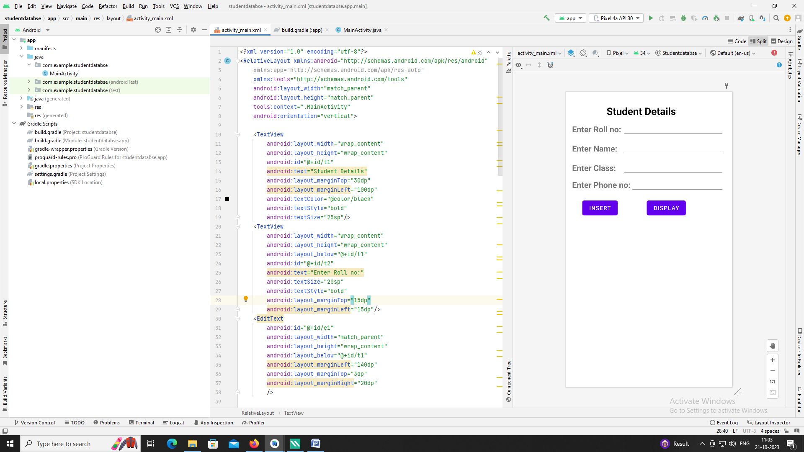

**Q2)** **2. Create table car (carno, name, model, colour). Create Application to perform the following**

**operations. (Using SQLite Database).**

**i) Update the car details whose colour is blue.**

**ii) Display all the records.**

**Xml code**

*<?*xml version="1.0" encoding="utf-8"*?>*<RelativeLayout xmlns:android="http://schemas.android.com/apk/res/android"  
 xmlns:app="http://schemas.android.com/apk/res-auto"  
 xmlns:tools="http://schemas.android.com/tools"  
 android:layout_width="match_parent"  
 android:layout_height="match_parent"  
 tools:context=".MainActivity"  
 android:orientation="vertical">  
  
 <TextView  
 android:layout_width="wrap_content"  
 android:layout_height="wrap_content"  
 android:id="@+id/t1"  
 android:text="Car Details"  
 android:layout_marginTop="30dp"  
 android:layout_marginLeft="100dp"  
 android:textColor="@color/black"  
 android:textStyle="bold"  
 android:textSize="25sp"/>  
 <TextView  
 android:layout_width="wrap_content"  
 android:layout_height="wrap_content"  
 android:layout_below="@+id/t1"  
 android:id="@+id/t2"  
 android:text="Enter Car no:"  
 android:textSize="20sp"  
 android:textStyle="bold"  
 android:layout_marginTop="15dp"  
 android:layout_marginLeft="15dp"/>  
 <EditText  
 android:id="@+id/e1"  
 android:layout_width="match_parent"  
 android:layout_height="wrap_content"  
 android:layout_below="@+id/t1"  
 android:layout_marginLeft="140dp"  
 android:layout_marginTop="3dp"  
 android:layout_marginRight="20dp"  
 />  
 <TextView  
 android:layout_width="wrap_content"  
 android:layout_height="wrap_content"  
 android:id="@+id/t3"  
 android:layout_below="@+id/e1"  
 android:text="Enter Name:"  
 android:textSize="20sp"  
 android:textStyle="bold"  
 android:layout_marginTop="15dp"  
 android:layout_marginLeft="15dp"/>  
 <EditText  
 android:layout_width="match_parent"  
 android:layout_height="wrap_content"  
 android:layout_below="@+id/e1"  
 android:layout_marginLeft="140dp"  
 android:layout_marginTop="3dp"  
 android:layout_marginRight="20dp"  
 android:id="@+id/e2" />  
 <TextView  
 android:layout_width="wrap_content"  
 android:layout_height="wrap_content"  
 android:id="@+id/t4"  
 android:layout_below="@+id/e2"  
 android:text="Enter Model:"  
 android:textSize="20sp"  
 android:textStyle="bold"  
 android:layout_marginTop="15dp"  
 android:layout_marginLeft="15dp"/>  
 <EditText  
 android:layout_width="match_parent"  
 android:layout_height="wrap_content"  
 android:layout_below="@+id/e2"  
 android:layout_marginLeft="140dp"  
 android:layout_marginTop="3dp"  
 android:layout_marginRight="20dp"  
 android:id="@+id/e3" />  
 <TextView  
 android:layout_width="wrap_content"  
 android:layout_height="wrap_content"  
 android:id="@+id/t5"  
 android:layout_below="@+id/t4"  
 android:text="Enter Colour:"  
 android:textSize="20sp"  
 android:textStyle="bold"  
 android:layout_marginTop="15dp"  
 android:layout_marginLeft="15dp"/>  
 <EditText  
 android:layout_width="match_parent"  
 android:layout_height="wrap_content"  
 android:layout_below="@+id/t4"  
 android:layout_marginLeft="140dp"  
 android:layout_marginTop="3dp"  
 android:layout_marginRight="20dp"  
 android:id="@+id/e4" />  
 <Button  
 android:layout_width="wrap_content"  
 android:layout_height="wrap_content"  
 android:id="@+id/b1"  
 android:text="Insert"  
 android:layout_below="@id/t5"  
 android:layout_marginLeft="40dp"  
 android:layout_marginTop="20dp"/>  
  
 <Button  
 android:id="@+id/b3"  
 android:layout_width="wrap_content"  
 android:layout_height="wrap_content"  
 android:text="UPDATE "  
 android:layout_below="@id/t5"  
 android:layout_marginLeft="230dp"  
 android:layout_marginTop="20dp"/>  
  
 <Button  
 android:layout_width="wrap_content"  
 android:layout_height="wrap_content"  
 android:id="@+id/b5"  
 android:text="Display"  
 android:layout_below="@id/b3"  
 android:layout_centerHorizontal="true"  
 android:layout_marginTop="20dp"/>  
  
  
</RelativeLayout>

**Java Code**

package com.example.database2;  
  
import androidx.appcompat.app.AppCompatActivity;  
  
import android.os.Bundle;  
import android.app.AlertDialog.Builder;  
import android.content.Context;  
import android.database.Cursor;  
import android.database.sqlite.SQLiteDatabase;  
import android.view.View;  
import android.view.View.OnClickListener;  
import android.widget.Button;  
import android.widget.EditText;  
  
public class MainActivity extends AppCompatActivity implements OnClickListener{  
 EditText Carno, Name, Model, Colour;  
 Button Insert, Update, ViewAll;  
 SQLiteDatabase db;  
  
 @Override  
 protected void onCreate(Bundle savedInstanceState) {  
 super.onCreate(savedInstanceState);  
 setContentView(R.layout.*activity_main*);  
 Carno = (EditText) findViewById(R.id.*e1*);  
 Name = (EditText) findViewById(R.id.*e2*);  
 Model = (EditText) findViewById(R.id.*e3*);  
 Colour = (EditText) findViewById(R.id.*e4*);  
 Insert = (Button) findViewById(R.id.*b1*);  
 Update = (Button) findViewById(R.id.*b3*);  
 ViewAll = (Button) findViewById(R.id.*b5*);  
 Insert.setOnClickListener(this);  
 Update.setOnClickListener(this);  
 ViewAll.setOnClickListener(this);  
 db = openOrCreateDatabase("CarDB", Context.*MODE_PRIVATE*, null);  
 db.execSQL("CREATE TABLE IF NOT EXISTS car1(carno VARCHAR,name VARCHAR,model VARCHAR,colour VARCHAR);");  
  
 }  
  
 public void onClick(View view) {  
 if (view == Insert) {  
 if (Carno.getText().toString().trim().length() == 0 ||  
 Name.getText().toString().trim().length() == 0 ||  
 Model.getText().toString().trim().length() == 0 ||  
 Colour.getText().toString().trim().length() == 0) {  
 showMessage("Error", "Please enter all values");  
 return;  
 }  
 db.execSQL("INSERT INTO car1 VALUES('" + Carno.getText() + "','" + Name.getText() + "','" + Model.getText() + "','" + Colour.getText() + "');");  
 showMessage("Success", "Record added");  
 clearText();  
 }  
 if (view == ViewAll) {  
 Cursor c = db.rawQuery("SELECT * FROM car1", null);  
 if (c.getCount() == 0) {  
 showMessage("Error", "No Records found");  
 return;  
 }  
 StringBuffer buffer = new StringBuffer();  
 while (c.moveToNext()) {  
 buffer.append("Carno:" + c.getString(0) + "\n");  
 buffer.append("Name:" + c.getString(1) + "\n");  
 buffer.append("Model:" + c.getString(2) + "\n");  
 buffer.append("Colour:" + c.getString(3) + "\n\n");  
 }  
 showMessage("Car Details", buffer.toString());  
 }  
 if (view == Update) {  
 if (Carno.getText().toString().trim().length() == 0) {  
 showMessage("Error", "Please Enter Colour");  
 return;  
 }  
 Cursor c = db.rawQuery("SELECT * FROM car1 WHERE colour='" + Colour.getText() + "'", null);  
 if (c.moveToFirst())  
 {  
 db.execSQL("UPDATE car1 SET name='" + Name.getText() + "',model='" + Model.getText() + "',carno='" + Carno.getText() + "' WHERE colour='" + Colour.getText() + "'");  
 showMessage("Success", "Record Modified");  
 }  
 else  
 {  
 showMessage("Error", "Invalid Colour");  
 }  
 clearText();  
 }  
  
 }  
  
  
 public void showMessage(String title, String message) {  
 Builder builder = new Builder(this);  
 builder.setCancelable(true);  
 builder.setTitle(title);  
 builder.setMessage(message);  
 builder.show();  
 }  
  
 public void clearText() {  
  
 Carno.setText("");  
 Name.setText("");  
 Model.setText("");  
 Colour.setText("");  
 Carno.requestFocus();  
 }  
}

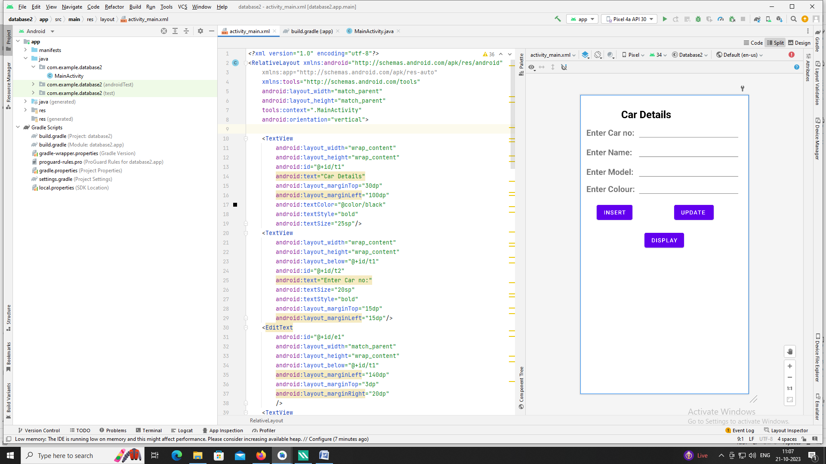

**Q3)**  **Create table Student (id, name, address, phno). Create Application for performing thefollowing operation on the table.**

**i) Insert New Student Details.**

**ii) Show All the Students Details**

**XML code:**

*<?*xml version="1.0" encoding="utf-8"*?>*<RelativeLayout xmlns:android="http://schemas.android.com/apk/res/android"  
 xmlns:app="http://schemas.android.com/apk/res-auto"  
 xmlns:tools="http://schemas.android.com/tools"  
 android:layout_width="match_parent"  
 android:layout_height="match_parent"  
 tools:context=".MainActivity">  
  
 <TextView  
 android:layout_width="wrap_content"  
 android:layout_height="wrap_content"  
 android:text="Student Details"  
 android:layout_marginTop="10dp"  
 android:layout_marginLeft="120dp"  
 android:textSize="25sp"  
 android:textStyle="bold"  
 android:textColor="@color/black"  
 android:id="@+id/title"/>  
 <TextView  
 android:layout_width="wrap_content"  
 android:layout_height="wrap_content"  
 android:id="@+id/t1"  
 android:text="Enter Student ID :"  
 android:layout_below="@id/title"  
 android:layout_marginTop="20dp"  
 android:layout_marginLeft="15dp"  
 android:textColor="@color/black"/>  
 <EditText  
 android:layout_width="200dp"  
 android:layout_height="wrap_content"  
 android:layout_alignParentRight="true"  
 android:layout_below="@id/title"  
 android:layout_marginRight="30dp"  
 android:id="@+id/e1"  
 android:inputType="number"/>  
 <TextView  
 android:layout_width="wrap_content"  
 android:layout_height="wrap_content"  
 android:id="@+id/t2"  
 android:text="Enter Student Name :"  
 android:layout_below="@id/t1"  
 android:layout_marginTop="25dp"  
 android:layout_marginLeft="15dp"  
 android:textColor="@color/black"/>  
 <EditText  
 android:layout_width="200dp"  
 android:layout_height="wrap_content"  
 android:layout_alignParentRight="true"  
 android:layout_below="@id/e1"  
 android:layout_marginRight="30dp"  
 android:id="@+id/e2"/>  
 <TextView  
 android:layout_width="wrap_content"  
 android:layout_height="wrap_content"  
 android:id="@+id/t3"  
 android:text="Enter Student Address :"  
 android:layout_below="@id/t2"  
 android:layout_marginTop="25dp"  
 android:layout_marginLeft="15dp"  
 android:textColor="@color/black"/>  
 <EditText  
 android:layout_width="200dp"  
 android:layout_height="wrap_content"  
 android:layout_alignParentRight="true"  
 android:layout_below="@id/e2"  
 android:layout_marginRight="30dp"  
 android:id="@+id/e3"/>  
 <TextView  
 android:layout_width="wrap_content"  
 android:layout_height="wrap_content"  
 android:id="@+id/t4"  
 android:text="Enter Student Phno :"  
 android:layout_below="@id/t3"  
 android:layout_marginTop="25dp"  
 android:layout_marginLeft="15dp"  
 android:textColor="@color/black"/>  
 <EditText  
 android:layout_width="200dp"  
 android:layout_height="wrap_content"  
 android:layout_alignParentRight="true"  
 android:layout_below="@id/e3"  
 android:layout_marginRight="30dp"  
 android:id="@+id/e4"  
 android:inputType="phone"/>  
 <Button  
 android:layout_width="wrap_content"  
 android:layout_height="wrap_content"  
 android:id="@+id/b1"  
 android:text="Insert"  
 android:layout_below="@id/t4"  
 android:layout_marginTop="25dp"  
 android:layout_marginLeft="150dp"/>  
 <Button  
 android:layout_width="wrap_content"  
 android:layout_height="wrap_content"  
 android:id="@+id/b2"  
 android:text="Display"  
 android:layout_below="@id/b1"  
 android:layout_marginTop="25dp"  
 android:layout_marginLeft="150dp"/>  
  
</RelativeLayout>

**Java code:**

package com.example.myapplication;

import androidx.appcompat.app.AppCompatActivity;

import android.os.Bundle;

import android.app.AlertDialog.Builder;

import android.content.Context;

import android.database.Cursor;

import android.database.sqlite.SQLiteDatabase;

import android.view.View;

import android.view.View.OnClickListener;

import android.widget.Button;

import android.widget.EditText;

import android.app.Activity;

public class MainActivity extends AppCompatActivity implements OnClickListener {

EditText Id, Name,Address, Phno;

Button Insert, ViewAll;

SQLiteDatabase db;

@Override

protected void onCreate(Bundle savedInstanceState) {

super.onCreate(savedInstanceState);

setContentView(R.layout.*activity_main*);

Id = (EditText) findViewById(R.id.*e1*);

Name = (EditText) findViewById(R.id.*e2*);

Address = (EditText) findViewById(R.id.*e3*);

Phno = (EditText) findViewById(R.id.*e4*);

Insert = (Button) findViewById(R.id.*b1*);

ViewAll = (Button) findViewById(R.id.*b2*);

Insert.setOnClickListener(this);

ViewAll.setOnClickListener(this);

db = openOrCreateDatabase("StudentDatabase1", Context.*MODE_PRIVATE*, null);

db.execSQL("CREATE TABLE IF NOT EXISTS students1(id VARCHAR,name VARCHAR,address VARCHAR,phno VARCHAR);");

}

public void onClick(View view)

{

if (view == Insert)

{

if (Id.getText().toString().trim().length() == 0 || Name.getText().toString().trim().length() == 0 || Address.getText().toString().trim().length() == 0||Phno.getText().toString().trim().length() == 0)

{

showMessage("Error", "Please enter all values");

return;

}

db.execSQL("INSERT INTO students1 VALUES('" + Id.getText() + "','" + Name.getText() + "','" + Address.getText() + "','"+Phno.getText()+"');");

showMessage("Success", "Record added");

clearText();

}

if (view == ViewAll)

{

Cursor c = db.rawQuery("SELECT * FROM students1", null);

if (c.getCount() == 0)

{

showMessage("Error", "No records found");

return;

}

StringBuffer buffer = new StringBuffer();

while (c.moveToNext())

{

buffer.append("ID:" + c.getString(0) + "\n");

buffer.append("Name:" + c.getString(1) + "\n");

buffer.append("Address:" + c.getString(2) + "\n");

buffer.append("Phno:" + c.getString(3) + "\n\n");

}

showMessage("Student Details:", buffer.toString());

}

}

public void showMessage(String title, String message) {

Builder builder = new Builder(this);

builder.setCancelable(true);

builder.setTitle(title);

builder.setMessage(message);

builder.show();

}

public void clearText() {

Id.setText("");

Name.setText("");

Address.setText("");

Phno.setText("");

Id.requestFocus();

}

}

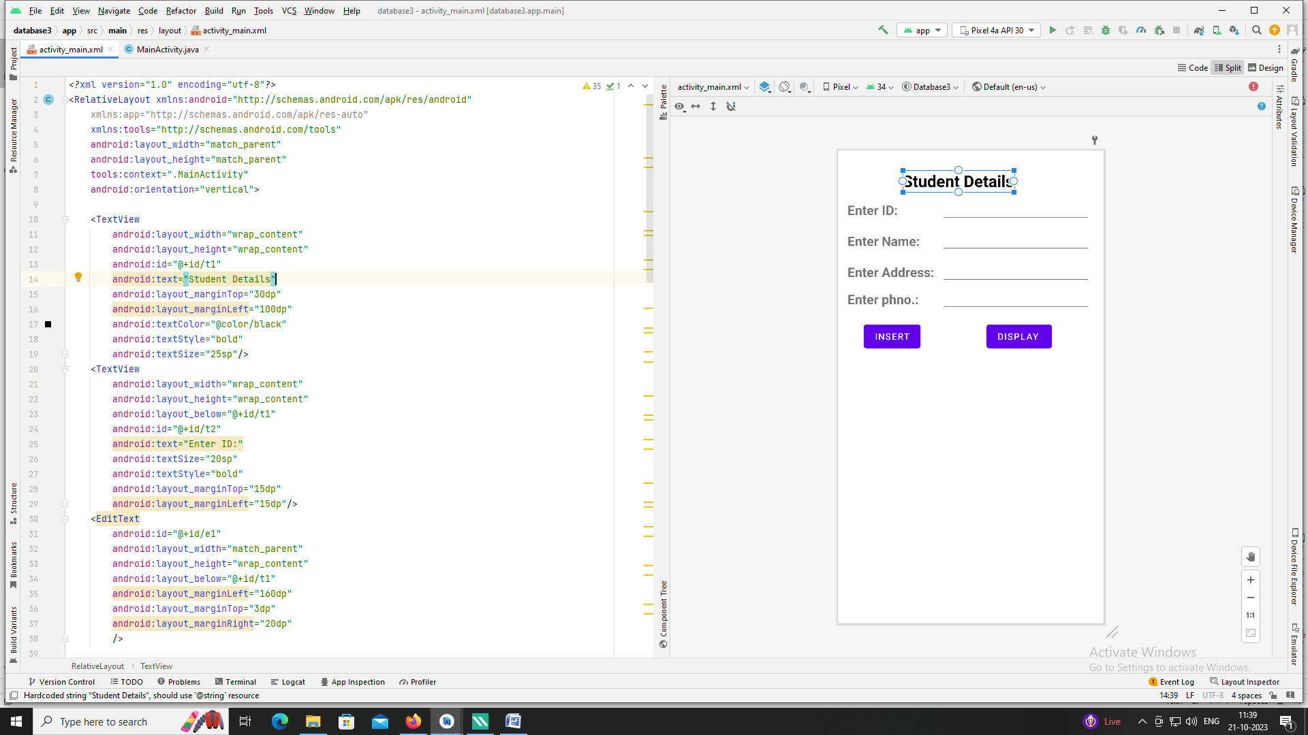

**4. Create Table project (pno, p_name, ptype, duration) and employee (id, e_name,**

**qualification, joindate) Project – employee have many to many relationship. Using the**

**database perform the following operation.**

**1) Add a new record into the table.**

**2) Accept a project name from the user and display information of employees**

**working on the project.**

**XML code:**

*<?*xml version="1.0" encoding="utf-8"*?>*<GridLayout xmlns:android="http://schemas.android.com/apk/res/android"  
 xmlns:app="http://schemas.android.com/apk/res-auto"  
 xmlns:tools="http://schemas.android.com/tools"  
 android:layout_width="match_parent"  
 android:layout_height="match_parent"  
 tools:context=".MainActivity"  
 android:columnCount="2"  
 android:rowCount="6">  
  
 <LinearLayout  
 android:layout_width="wrap_content"  
 android:layout_height="wrap_content"  
 android:orientation="vertical"  
 android:layout_marginTop="10dp"  
 android:layout_marginLeft="30dp">  
  
 <TextView  
 android:id="@+id/pno"  
 android:layout_width="wrap_content"  
 android:layout_height="wrap_content"  
 android:text="Pno :"  
 android:textSize="20sp"/>  
 <TextView  
 android:id="@+id/pname"  
 android:layout_marginTop="15dp"  
 android:layout_width="wrap_content"  
 android:layout_height="wrap_content"  
 android:text="Pname :"  
 android:textSize="20sp"  
 />  
 <TextView  
 android:id="@+id/ptype"  
 android:layout_marginTop="15dp"  
 android:layout_width="wrap_content"  
 android:layout_height="wrap_content"  
 android:text="Ptype :"  
 android:textSize="20sp"/>  
 <TextView  
 android:id="@+id/duration"  
 android:layout_marginTop="15dp"  
 android:layout_width="wrap_content"  
 android:layout_height="wrap_content"  
 android:text="Duration :"  
 android:textSize="20sp"/>  
 </LinearLayout>  
  
  
 <LinearLayout  
 android:layout_width="wrap_content"  
 android:layout_height="wrap_content"  
 android:orientation="vertical">  
  
 <EditText  
 android:id="@+id/ed_pno"  
 android:layout_width="200dp"  
 android:layout_height="wrap_content"  
 android:hint="Enter project number"  
 android:textSize="15sp"/>  
 <EditText  
 android:id="@+id/ed_pname"  
 android:layout_width="200dp"  
 android:layout_height="wrap_content"  
 android:hint="Enter project name"  
 android:textSize="15sp"/>  
 <EditText  
 android:id="@+id/ed_type"  
 android:layout_width="200dp"  
 android:layout_height="wrap_content"  
 android:hint="Enter project type"  
 android:textSize="15sp"/>  
 <EditText  
 android:id="@+id/ed_duration"  
 android:layout_width="200dp"  
 android:layout_height="wrap_content"  
 android:hint="Enter project duration"  
 android:textSize="15sp"/>  
  
 </LinearLayout>  
  
 <LinearLayout  
 android:layout_height="wrap_content"  
 android:layout_width="wrap_content"  
 android:layout_marginLeft="80dp"  
 android:orientation="vertical"  
 android:layout_marginTop="40dp">  
 <Button  
 android:id="@+id/addbtn"  
 android:layout_width="wrap_content"  
 android:layout_height="50dp"  
 android:text="ADD"  
 android:textSize="10sp"/>  
  
  
 </LinearLayout>  
 <LinearLayout  
 android:layout_width="wrap_content"  
 android:layout_height="wrap_content"  
 android:layout_marginTop="40dp"  
 android:layout_marginLeft="110dp">  
 <Button  
 android:id="@+id/viewbtn"  
 android:layout_width="wrap_content"  
 android:layout_height="50dp"  
 android:text="VIEW"  
 android:textSize="10sp"/>  
  
 </LinearLayout>  
  
 <LinearLayout  
 android:layout_width="wrap_content"  
 android:layout_height="wrap_content"  
 android:orientation="vertical"  
 android:layout_marginTop="10dp"  
 android:layout_marginLeft="30dp">  
  
 <TextView  
 android:id="@+id/eid"  
 android:layout_width="wrap_content"  
 android:layout_height="wrap_content"  
 android:text="EID :"  
 android:textSize="20sp"/>  
 <TextView  
 android:id="@+id/ename"  
 android:layout_marginTop="15dp"  
 android:layout_width="wrap_content"  
 android:layout_height="wrap_content"  
 android:text="Ename :"  
 android:textSize="20sp"  
 />  
 <TextView  
 android:id="@+id/qualification"  
 android:layout_marginTop="15dp"  
 android:layout_width="wrap_content"  
 android:layout_height="wrap_content"  
 android:text="QUALIFICATION :"  
 android:textSize="20sp"/>  
 <TextView  
 android:id="@+id/joindate"  
 android:layout_marginTop="15dp"  
 android:layout_width="wrap_content"  
 android:layout_height="wrap_content"  
 android:text="JOIN DATE :"  
 android:textSize="20sp"/>  
 </LinearLayout>  
  
  
 <LinearLayout  
 android:layout_width="wrap_content"  
 android:layout_height="wrap_content"  
 android:orientation="vertical">  
  
 <EditText  
 android:id="@+id/ed_eid"  
 android:layout_width="200dp"  
 android:layout_height="wrap_content"  
 android:hint="Enter employee number"  
 android:textSize="15sp"/>  
 <EditText  
 android:id="@+id/ed_ename"  
 android:layout_width="200dp"  
 android:layout_height="wrap_content"  
 android:hint="Enter employee name"  
 android:textSize="15sp"/>  
 <EditText  
 android:id="@+id/ed_qualification"  
 android:layout_width="200dp"  
 android:layout_height="wrap_content"  
 android:hint="Enter qualification"  
 android:textSize="15sp"/>  
 <EditText  
 android:id="@+id/ed_joindate"  
 android:layout_width="200dp"  
 android:layout_height="wrap_content"  
 android:hint="Enter join date"  
 android:textSize="15sp"/>  
 </LinearLayout>  
  
  
 <LinearLayout>  
 <Button  
 android:layout_marginTop="20dp"  
 android:layout_marginLeft="80dp"  
 android:id="@+id/addemp"  
 android:layout_width="wrap_content"  
 android:layout_height="wrap_content"  
 android:text="ADD"/>  
 </LinearLayout>  
 <LinearLayout>  
  
 <Button  
 android:layout_marginTop="20dp"  
 android:layout_marginLeft="80dp"  
 android:id="@+id/viewemp"  
 android:layout_width="wrap_content"  
 android:text="view"  
 android:layout_height="wrap_content"/>  
 </LinearLayout>  
  
 <LinearLayout>  
 <Button  
 android:id="@+id/thirdtableadd"  
 android:layout_width="wrap_content"  
 android:layout_height="wrap_content"  
 android:layout_marginLeft="80dp"  
 android:layout_marginTop="20dp"  
 android:text="Insert"/>  
 </LinearLayout>  
 <LinearLayout>  
 <Button  
 android:layout_marginTop="20dp"  
 android:layout_marginLeft="80dp"  
 android:id="@+id/thirdtableview"  
 android:layout_width="wrap_content"  
 android:layout_height="wrap_content"  
 android:text="View"/>  
 </LinearLayout>  
  
 <LinearLayout  
 android:layout_width="wrap_content"  
 android:layout_height="wrap_content"  
 android:layout_marginTop="40dp"  
 android:layout_marginLeft="30dp"  
 android:orientation="horizontal">  
  
 <TextView  
 android:layout_width="wrap_content"  
 android:layout_height="wrap_content"  
 android:text="Employee search :"  
 android:textSize="18sp"  
 />  
 </LinearLayout>  
  
 <LinearLayout  
 android:layout_width="wrap_content"  
 android:layout_height="wrap_content"  
 android:layout_marginLeft="0dp"  
 android:layout_marginTop="20dp">  
  
 <EditText  
 android:id="@+id/ed_pesearch"  
 android:layout_width="180dp"  
 android:layout_height="wrap_content"  
 android:hint="Enter project number"/>  
 </LinearLayout>  
  
 <Button  
 android:id="@+id/pseasrch"  
 android:layout_width="wrap_content"  
 android:layout_height="wrap_content"  
 android:layout_marginTop="10dp"  
 android:layout_marginLeft="100dp"  
 android:text="Search"/>  
</GridLayout>

**Java code:**

package com.example.myapplication;

import androidx.appcompat.app.AppCompatActivity;

import android.annotation.SuppressLint;

import android.app.AlertDialog;

import android.content.Context;

import android.content.DialogInterface;

import android.database.Cursor;

import android.database.sqlite.SQLiteDatabase;

import android.view.View.OnClickListener;

import android.os.Bundle;

import android.view.View;

import android.widget.Button;

import android.widget.EditText;

import android.widget.Toast;

public class MainActivity extends AppCompatActivity implements OnClickListener {

SQLiteDatabase db;

EditText pno,pname,ptype,duration,eid,ename,qualification,joindate,psearch;

Button b1,b2,b3,b4,b5,b6,b7;

@Override

protected void onCreate(Bundle savedInstanceState) {

super.onCreate(savedInstanceState);

setContentView(R.layout.*activity_main*);

pno = (EditText) findViewById(R.id.*ed_pno*);

pname = (EditText) findViewById(R.id.*ed_pname*);

ptype = (EditText) findViewById(R.id.*ed_type*);

duration = (EditText) findViewById(R.id.*ed_duration*);

eid = (EditText) findViewById(R.id.*ed_eid*);

ename = (EditText) findViewById(R.id.*ed_ename*);

qualification = (EditText) findViewById(R.id.*ed_qualification*);

joindate = (EditText) findViewById(R.id.*ed_joindate*);

psearch = (EditText) findViewById(R.id.*ed_pesearch*);

b1 = (Button) findViewById(R.id.*addbtn*);

b2 = (Button) findViewById(R.id.*viewbtn*);

b3 = (Button) findViewById(R.id.*addemp*);

b4 = (Button) findViewById(R.id.*viewemp*);

b5 = (Button) findViewById(R.id.*pseasrch*);

b6 = (Button) findViewById(R.id.*thirdtableadd*);

b7 = (Button) findViewById(R.id.*thirdtableview*);

db = openOrCreateDatabase("assignment2", Context.*MODE_PRIVATE*, null);

db.execSQL("CREATE TABLE IF NOT EXISTS project(pno number primary key, pname VARCHAR, ptype VARCHAR,duration number);");

db.execSQL("CREATE TABLE IF NOT EXISTS employee(eid number primary key, ename VARCHAR, qualification VARCHAR,joindate number);");

*//db.execSQL("CREATE TABLE IF NOT EXISTS pro_emp(p_no number foreign key references project(pno),e_id number foreign key references employee(eid));");*

db.execSQL("CREATE TABLE IF NOT EXISTS pro_emp(p_no number REFERENCES project(pno), e_id number REFERENCES employee(eid))");

b1.setOnClickListener(this);

b2.setOnClickListener(this);

b3.setOnClickListener(this);

b4.setOnClickListener(this);

b5.setOnClickListener(this);

b6.setOnClickListener(this);

b7.setOnClickListener(this);

}

public void showMessage(String title,String message)

{

AlertDialog.Builder builder=new AlertDialog.Builder(this);

builder.setCancelable(true); builder.setTitle(title);

builder.setMessage(message);

builder.show();

}*//show*

public void clearText()

{

pno.setText("");

pname.setText("");

ptype.setText("");

duration.setText("");

*//e_pid.setText("");*

*//e_jdate.setText("");*

*//e_quali.setText("");*

*//e_name.setText("");*

pno.requestFocus();

}*//clear*

public void onClick(View view){

if (view == b1) {

if (pno.getText().toString().trim().length() == 0 || pname.getText().toString().trim().length() == 0 || ptype.getText().toString().trim().length() == 0||duration.getText().toString().trim().length()==0) {

Toast.*makeText*(this, "\"please enter the values", Toast.*LENGTH_SHORT*).show();

return;

}

db.execSQL("INSERT INTO project VALUES('" + pno.getText() + "','" + pname.getText() + "','" + ptype.getText() + "','" + duration.getText() + "');");

*//db.execSQL("INSERT INTO emp VALUES('" + e_id.getText() + "','" + e_name.getText() + "','" + e_quali.getText() + "','" + e_jdate.getText() + "');");*

*//db.execSQL("INSERT INTO pro_emp VALUES('" + e_pid.getText() + "','" + e_id.getText() + "');");*

showMessage("Success", "Record added");

*//11clearText();*

}*//b1*

if(view==b2)

{

Cursor c = db.rawQuery("SELECT * FROM project",null );

if(c.getCount() == 0){

Toast.*makeText*(MainActivity.this," No Records found",Toast.*LENGTH_SHORT*).show();

return;

}

StringBuilder b = new StringBuilder();

while(c.moveToNext()){

b.append("Project no :").append(c.getString(0)).append("\n");

b.append("Project name :").append(c.getString(1)).append("\n");

b.append("Project type:").append(c.getString(2)).append("\n");

b.append("Duration :").append(c.getString(3)).append("\n");

}

Toast.*makeText*(MainActivity.this, b.toString(), Toast.*LENGTH_LONG*).show();

}*////b2*

if(view==b3)

{

try {

if (eid.getText().toString().trim().length() == 0 || ename.getText().toString().trim().length() == 0 || qualification.getText().toString().trim().length() == 0 || joindate.getText().toString().trim().length() == 0) {

Toast.*makeText*(MainActivity.this, "Some fields are empty!!", Toast.*LENGTH_SHORT*).show();

return;

}

db.execSQL("INSERT INTO employee VALUES('" + eid.getText() + "','" + ename.getText() + "','" + qualification.getText()+ "','" + joindate.getText()+ "');");

Toast.*makeText*(MainActivity.this, "Record Inserted successfully!!", Toast.*LENGTH_SHORT*).show();

}

catch (Exception e){

Toast.*makeText*(MainActivity.this, e.toString(), Toast.*LENGTH_SHORT*).show();

return;

}

}*//b3*

if(view==b4)

{

Cursor c = db.rawQuery("SELECT * FROM employee",null );

if(c.getCount() == 0){

Toast.*makeText*(MainActivity.this," No Records found",Toast.*LENGTH_SHORT*).show();

return;

}

StringBuilder b = new StringBuilder();

while(c.moveToNext()){

b.append("Employee id:").append(c.getString(0)).append("\n");

b.append("Employee name :").append(c.getString(1)).append("\n");

b.append("Qualification:").append(c.getString(2)).append("\n");

b.append("Join Date:").append(c.getString(3)).append("\n");

}

Toast.*makeText*(MainActivity.this, b.toString(), Toast.*LENGTH_LONG*).show();

}*//b4*

if(view==b5)

{

Cursor c=db.rawQuery("SELECT eid,ename FROM employee,project,pro_emp where employee.eid=pro_emp.e_id and project.pno=pro_emp.p_no and pno='"+psearch.getText()+"'",null);

if(c.getCount()==0)

{

showMessage("Error","No Records Found");

return;

}*//getcount*

StringBuffer b=new StringBuffer();

while(c.moveToNext())

{

b.append("e_id:"+c.getString(0)+"\n");

b.append("e_name:"+c.getString(1)+"\n");

;

}*//while*

showMessage("Employee Details",b.toString());

}*//b5*

if(view==b6) {

try {

db.execSQL("INSERT into pro_emp values('" + pno.getText() + "','" + eid.getText()+ "');");

Toast.*makeText*(MainActivity.this, "Record inserted successfully!!", Toast.*LENGTH_SHORT*).show();

} catch (Exception e) {

Toast.*makeText*(MainActivity.this, e.toString(), Toast.*LENGTH_SHORT*).show();

}

}*//b6*

if(view==b7)

{

Cursor c = db.rawQuery("SELECT * FROM pro_emp",null );

if(c.getCount() == 0){

Toast.*makeText*(MainActivity.this," No Records found",Toast.*LENGTH_SHORT*).show();

return;

}

StringBuilder b = new StringBuilder();

while(c.moveToNext()){

b.append("Project no :").append(c.getString(0)).append("\n");

b.append("Employee id :").append(c.getString(1)).append("\n");

}

Toast.*makeText*(MainActivity.this, b.toString(), Toast.*LENGTH_LONG*).show();

}

}*//click*

}*//class*

**5. NOT THERE**

**6. Write an android application using SQLite to create table and perform CRUD operations (Example. COURSE table (ID, Name, Duration, Description), perform ADD, UPDATE, DELETE and READ operations).**

**XML code:**

*<?*xml version="1.0" encoding="utf-8"*?>*

<RelativeLayout xmlns:android="http://schemas.android.com/apk/res/android"

xmlns:app="http://schemas.android.com/apk/res-auto"

xmlns:tools="http://schemas.android.com/tools"

android:layout_width="match_parent"

android:layout_height="match_parent"

tools:context=".MainActivity">

<TextView

android:layout_width="wrap_content"

android:layout_height="wrap_content"

android:id="@+id/t1"

android:text="ID :"

android:textSize="20sp"

android:layout_marginTop="30dp"

android:layout_marginLeft="20dp"/>

<EditText

android:layout_width="200dp"

android:layout_height="wrap_content"

android:layout_marginTop="18dp"

android:layout_marginLeft="80dp"

android:id="@+id/eid"/>

<TextView

android:layout_width="wrap_content"

android:layout_height="wrap_content"

android:id="@+id/t2"

android:text="Name:"

android:textSize="20sp"

android:layout_marginTop="20dp"

android:layout_marginLeft="20dp"

android:layout_below="@id/t1"/>

<EditText

android:layout_width="200dp"

android:layout_height="wrap_content"

android:layout_marginTop="60dp"

android:layout_marginLeft="90dp"

android:id="@+id/ename"/>

<TextView

android:layout_width="wrap_content"

android:layout_height="wrap_content"

android:id="@+id/t3"

android:text="Duration:"

android:textSize="20sp"

android:layout_marginTop="20dp"

android:layout_marginLeft="20dp"

android:layout_below="@id/t2"/>

<EditText

android:layout_width="200dp"

android:layout_height="wrap_content"

android:layout_marginTop="110dp"

android:layout_marginLeft="110dp"

android:id="@+id/eduration"/>

<TextView

android:layout_width="wrap_content"

android:layout_height="wrap_content"

android:id="@+id/t4"

android:text="Description:"

android:textSize="20sp"

android:layout_marginTop="20dp"

android:layout_marginLeft="20dp"

android:layout_below="@id/t3"/>

<EditText

android:layout_width="200dp"

android:layout_height="wrap_content"

android:layout_marginTop="160dp"

android:layout_marginLeft="140dp"

android:id="@+id/edescription"/>

<Button

android:layout_width="wrap_content"

android:layout_height="wrap_content"

android:id="@+id/badd"

android:text="Add"

android:layout_below="@id/t4"

android:layout_marginTop="15dp"

android:layout_marginLeft="20dp"/>

<Button

android:layout_width="wrap_content"

android:layout_height="wrap_content"

android:id="@+id/bdel"

android:text="Delete"

android:layout_below="@id/badd"

android:layout_marginTop="15dp"

android:layout_marginLeft="20dp"/>

<Button

android:layout_width="wrap_content"

android:layout_height="wrap_content"

android:id="@+id/bup"

android:text="Update"

android:layout_below="@id/bdel"

android:layout_marginTop="15dp"

android:layout_marginLeft="20dp"/>

<Button

android:layout_width="wrap_content"

android:layout_height="wrap_content"

android:id="@+id/bview"

android:text="View all"

android:layout_below="@id/bup"

android:layout_marginTop="15dp"

android:layout_marginLeft="20dp"/>

</RelativeLayout>

**Java code:**

package com.example.myapplication;

import androidx.appcompat.app.AppCompatActivity;

import android.annotation.SuppressLint;

import android.os.Bundle;

import android.widget.Button;

import android.widget.EditText;

import android.content.Context;

import android.database.sqlite.SQLiteDatabase;

import android.database.Cursor;

import android.view.View;

import android.view.View.OnClickListener;

import android.app.AlertDialog.Builder;

import android.widget.Toast;

public class MainActivity extends AppCompatActivity implements OnClickListener

{

EditText id,name, dur,des;

Button b1,b4,b2,b3;

SQLiteDatabase db;

String title,message;

@SuppressLint("MissingInflatedId")

@Override

protected void onCreate(Bundle savedInstanceState) {

super.onCreate(savedInstanceState);

setContentView(R.layout.*activity_main*);

id=(EditText) findViewById (R.id.*eid*);

name=(EditText) findViewById(R.id.*ename*);

dur = (EditText) findViewById(R.id.*eduration*);

des=(EditText) findViewById(R.id.*edescription*);

b1=(Button) findViewById(R.id.*badd*);

b4=(Button) findViewById(R.id.*bview*);

b2=(Button) findViewById(R.id.*bdel*);

b3=(Button) findViewById(R.id.*bup*);

b1.setOnClickListener(this);

b2.setOnClickListener(this);

b3.setOnClickListener(this);

b4.setOnClickListener(this);

db=openOrCreateDatabase("Course",Context.*MODE_PRIVATE*, null);

db.execSQL("CREATE TABLE IF NOT EXISTS course(id VARCHAR,name VARCHAR,dur VARCHAR,des VARCHAR);");

showMessage("Success","Table Created");

}

public void showMessage(String title,String message)

{

Builder builder=new Builder(this);

builder.setCancelable(true);

builder.setTitle(title);

builder.setMessage(message);

builder.show();

}

public void clearText()

{

id.setText("");

name.setText("");

dur.setText("");

des.setText("");

id.requestFocus();

}

@Override

public void onClick(View view){

if(view==b1)

{

if(id.getText().toString().trim().length()==0||name.getText().toString().trim().length()==0|| dur.getText().toString().trim().length()==0||des.getText().toString().trim().length()==0)

{

Toast.*makeText*(this,"please enter the value",Toast.*LENGTH_SHORT*).show();

return;

}

db.execSQL("insert into course values('"+id.getText()+"','"+name.getText()+"','"+dur.getText()+"','"+des.getText()+"');");

showMessage("Success","Record added");

clearText();

}

if (view==b4)

{

Cursor c=db.rawQuery("select * from course",null);

if(c.getCount()==0)

{

showMessage("Error","No Record Found");

return;

}

StringBuffer b=new StringBuffer();

while(c.moveToNext())

{

b.append("Course id:"+c.getString(0)+"\n");

b.append("Course name:"+c.getString(1)+"\n");

b.append("Course duration:"+c.getString(2)+"\n");

b.append("Course description:"+c.getString(3)+"\n");

}

showMessage("Course Details",b.toString());

}

if(view==b2)

{

if(id.getText().toString().trim().length()==0)

{

showMessage("Error","Please Enter the Employee ID");

return;

}

Cursor c=db.rawQuery("select * from course where id='"+id.getText()+"'",null);

if(c.moveToFirst())

{

db.execSQL("delete from course where id='"+id.getText()+"'");

showMessage("Success","Record Deleted");

}

else

{

showMessage("Error","Invalid Course ID");

}

clearText();

}

if(view==b3)

{

if(id.getText().toString().trim().length()==0)

{

showMessage("Error", "Please enter the course id");

return;

}

Cursor c=db.rawQuery("select * from course where id='"+id.getText()+"'",null);

if(c.moveToFirst())

{

db.execSQL("update course set name='"+name.getText()+"',dur='"+dur.getText()+"'where id='"+id.getText()+"'");

showMessage("Success","Record Modified");

}

else

{

showMessage("Error","Invalid Course ID");

return;

}

}

clearText();

}

}